me7120 Project 3

wright state university

Fall 2016

Students: Philip Bear, Jeremy Geaslen, Andy Turner

Date: 9 Dec 2016

Professor: Dr. Joseph Slater

Contents

Problem Statement 1

Results and discussion 2

Appendix 7

# Problem Statement

* Program the Newmark beta method and apply it to the geometry shown in Figure 11.17-1 subject to the loads of section 11.18.

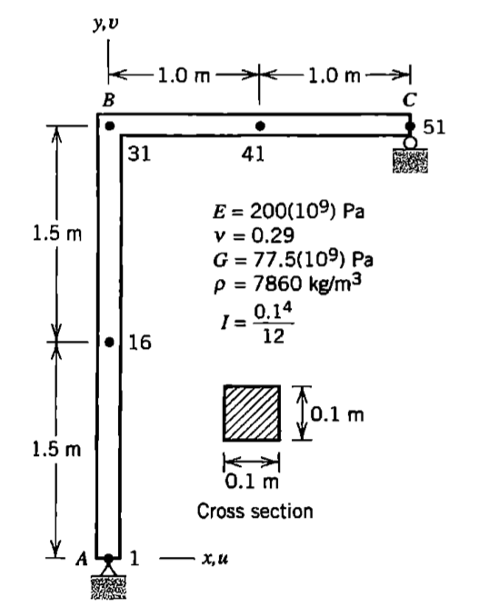

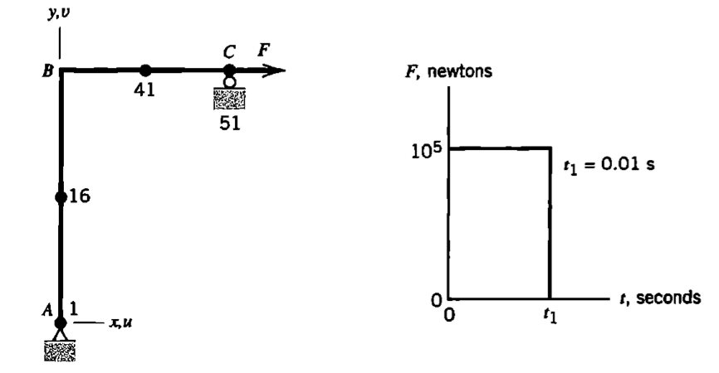

* Perform the comparison of all of the five Newmark beta methods shown in 11.13-1, similar to what is shown in figure 11.18-2 and table 11.18-1.

**Table 1:** Stability and Accuracy of Selected Implicit Direct Integration Methods

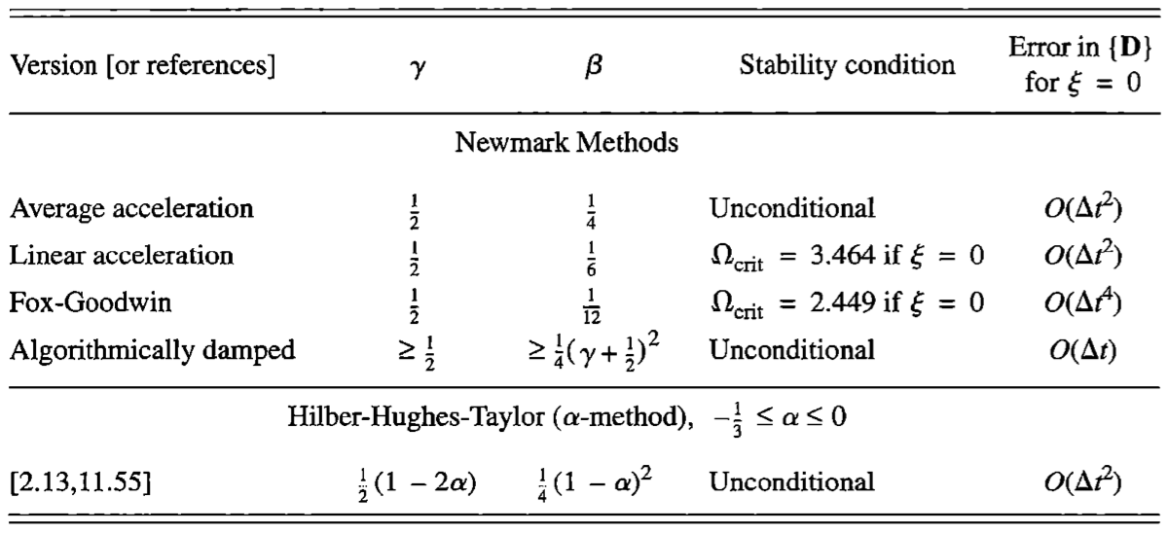

# Results

|  |  |  |  |  |  |  |
| --- | --- | --- | --- | --- | --- | --- |
| ***Method*** | ***γ*** | ***β*** | ***Δt*** | ***Max Disp.*** | ***Max***  ***Vel.*** | ***Max Acc.*** |
| Average Acceleration | 0.5 | 0.25 | 0.0001 | 0.004176 | 1.548 | 82,310 |
| Linear Acceleration | 0.5 | 0.167 | 0.000001 | 0.004035 | 2.323 | 129,100 |
| Fox-Goodwin | 0.5 | 0.083 | 0.000001 | 0.004039 | 2.294 | 132,300 |
| Algorithmically Damped | 0.75 | 0.39062 | 0.0001 | 0.003839 | 0.5044 | 1,427 |
| Hilber-Hughes-Taylor (α=-0.1) | 0.6 | 0.3025 | 0.0001 | 0.003957 | 0.5906 | 2,379 |

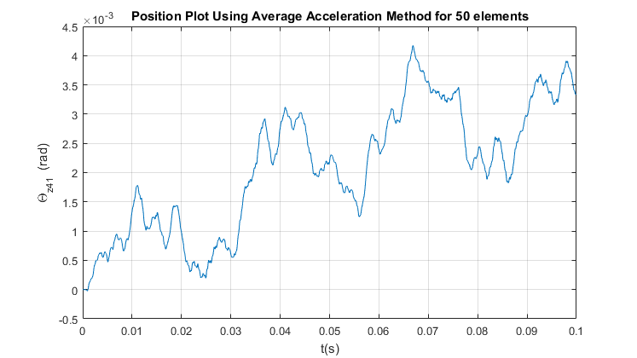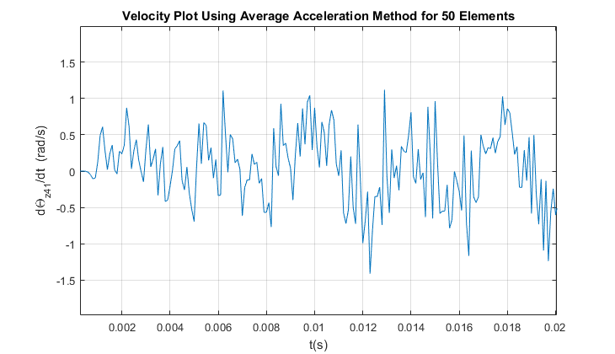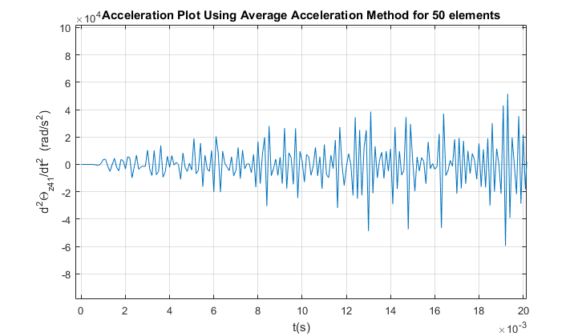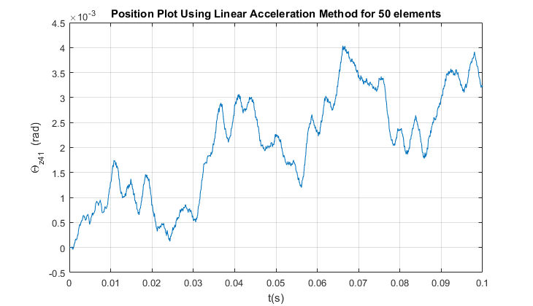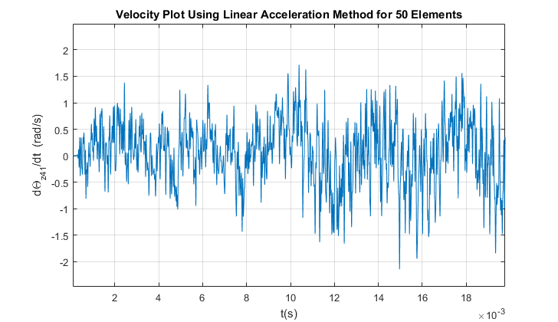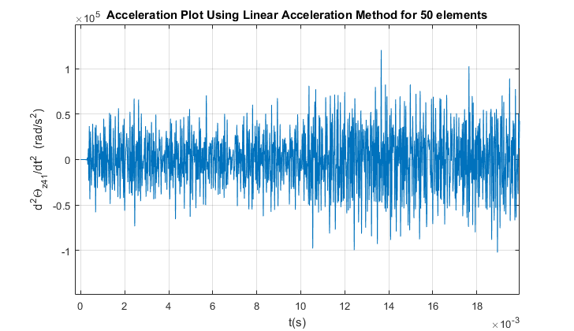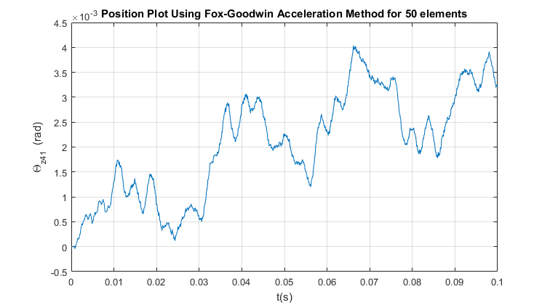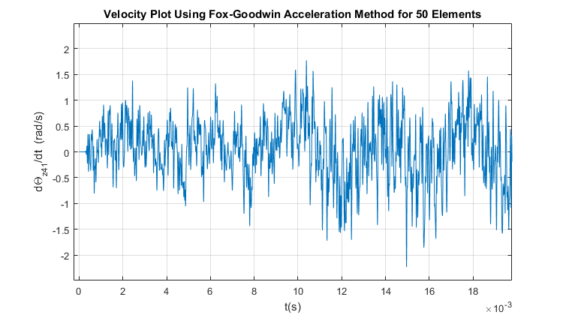

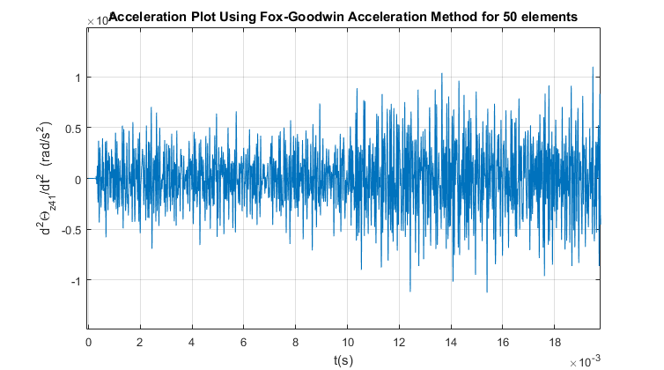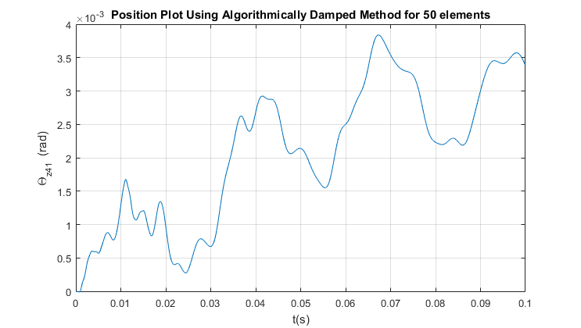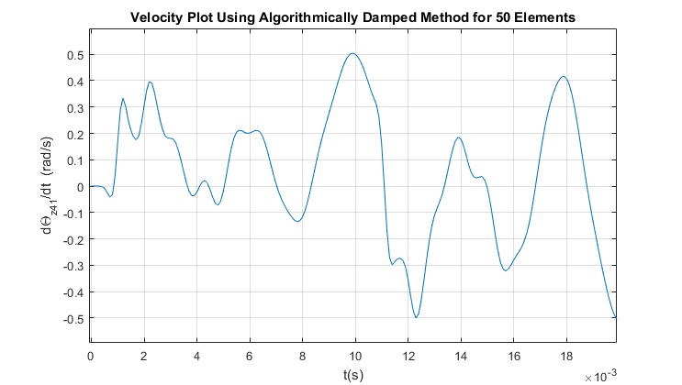

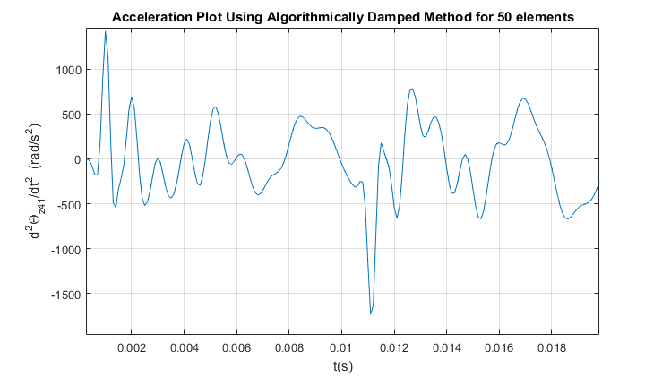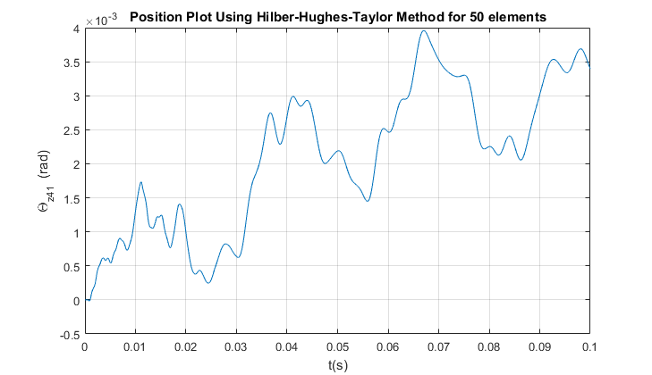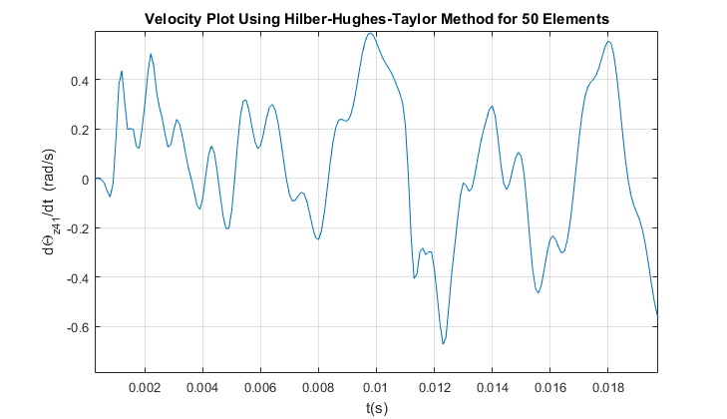

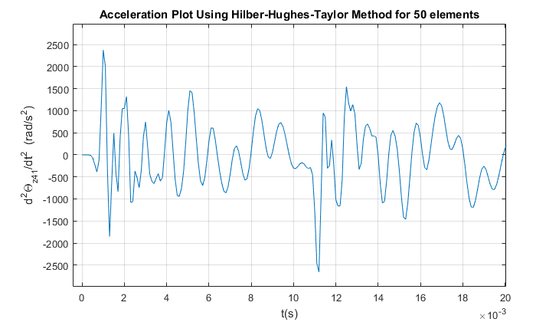

# Conclusion

The five Newmark Beta Methods were used to analyze the dynamic behavior of the L-Frame shown in the problem statement above. All values for gamma and beta, that were used for the analysis, are shown in Table 1. The first three methods yielded similar results for the maximum displacement. However, the maximum velocity and acceleration increased as beta decreased. A smaller delta t was needed to create adequate plots on the Linear Acceleration and Fox-Goodwin method. The results from the Algorithmically Damped and Hilber-Hughes-Taylor method differed greatly when looking at the maximum velocity and acceleration. However, the maximum displacements stayed consistent between all five methods of Implicit Direct Integration.